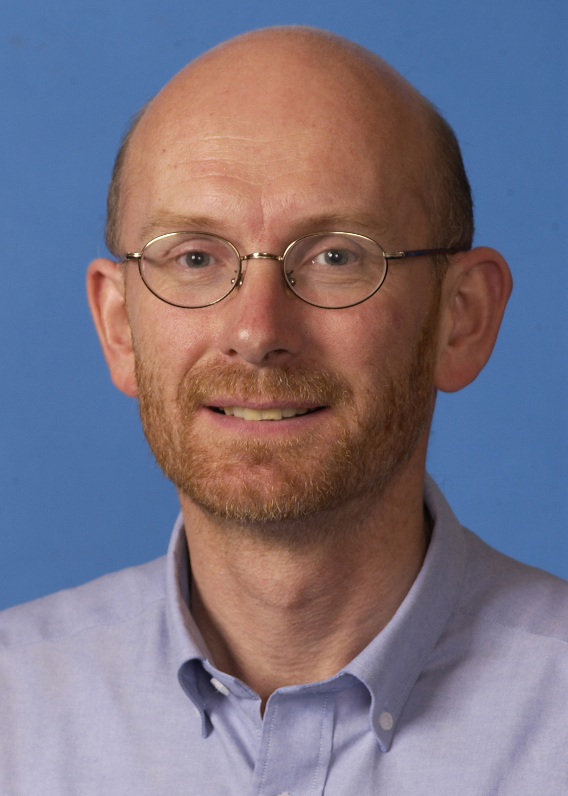

Andrew J. Dugmore

Geography, School of GeoSciences, University of Edinburgh, Drummond Street, Edinburgh EH8 9XP, Scotland, UK
Office telephone 44 131 650 9847
Direct telephone line 44 131 650 8156
email andrew.dugmore@ed.ac.uk

Biography
I am a physical geographer and my main research interests lie in understanding human-environment interactions, environmental change over timescales from decades to millennia, and the significance of both environmental and climate change for human society. A principle region of interest is the North Atlantic and a key research theme is the development and application of tephrochronology which I have applied to a wide range of environmental and archaeological questions. I am currently Professor of Geosciences at the University of Edinburgh and Associate Director of the Human-Ecodynamics Research Centre in New York.

Aims for the NABO meeting
I would like to discuss ways in which we may be able to anticipate threshold change in complex socio-ecological systems. In particular, can we identify signs of critical slowing down (increased recovery times to minor perturbations that may be shown as increased variance and autocorrelation) or ‘flickering’ between alternate states (that may be shown in measures of skewness). I am currently developing measures of tephra layer morphology that reflect land surface resilience and hold the potential to both anticipate threshold crossing events and identified ‘near-misses’ in the past:- times when a land surface system drew close to, but did not cross, a tipping point to an alternate state (Streeter and Dugmore Anticipating land surface change PNAS 2013 110 (15) 5779-5784).

