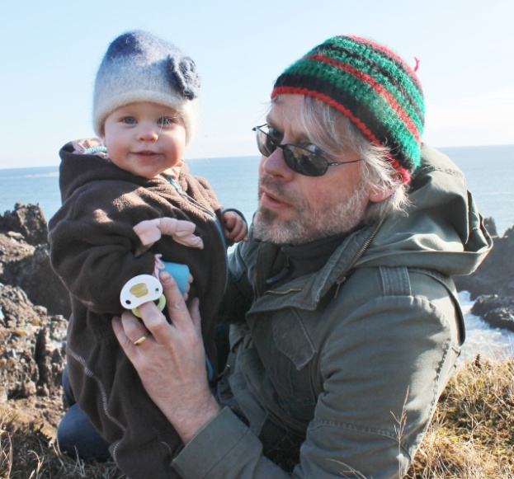
Ragnar Edvardsson
University of Iceland, Research Centres
Aðalstræti 21, 415 Bolungarvík, Iceland
Tel: + 354 893 7636
red@hi.is
Biography
Ragnar Edvardsson is an archaeologist with a long experience in several aspects of archaeological research, including North Atlantic archaeology, underwater archaeology, fisheries archaeology and excavation methods. Employed as a research scientist at the University of Iceland’s Institute of Research Centres current research includes the geographical and temporal extent and continuation of fisheries and fish trade in medieval Iceland, European trade in pre monopolised Iceland and the role of marine resources in Iceland’s medieval economy, trade and social development. To approach these topics Ragnar uses surveying, excavation and dating of fishing sites and stations, surveying and excavation of sunken trading vessels, document research and interdisciplinary reconstruction of the marine resource.
Aims for NABO Meeting
Meeting fellow scientists. Learn about ongoing projects. The aim is also to introduce the current research, especially into fisheries and fish trade.

