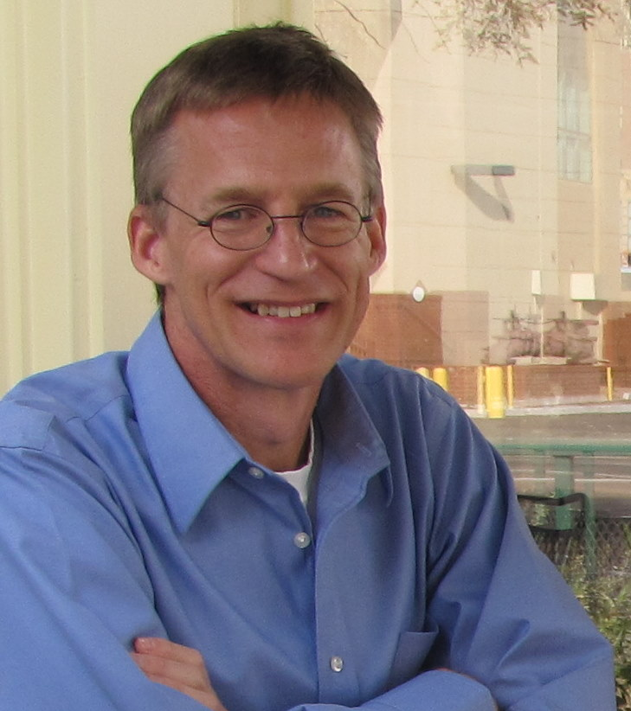 | Scott E. Ingram  University of Texas at Arlington  Visiting Assistant Professor  Home:  3929 Clayton Rd W  Fort Worth, TX 76116  Tel: 480-272-4058  singram@asu.edu

Biography
I am an archaeologist, anthropologist, and Visiting Assistant Professor at the University of Texas at Arlington. My research considers human and environmental interactions with an emphasis on using insights from archaeological research to address contemporary problems such as human responses to climate change. Research objectives also include advancing understanding of classic archaeological problems (e.g., cultural transition, regional depopulation, “collapses”) with regional-scale settlement and environmental data and innovative methods and analysis.
Aims for NABO Meeting
At the NABO meeting I hope to further my knowledge and understanding of the North Atlantic region (past and present) to contribute to my comparative climate change/social transformations research with the U.S. Southwest. I will also meet with colleagues and develop new research and collaborative efforts.

