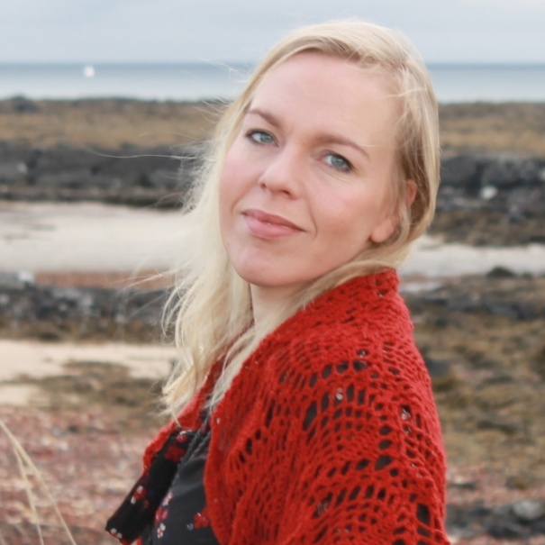 | Guðbjörg Ásta Ólafsdóttir  Vör Marine Research Centre  Nordurtangi, 355 Ólafsvík, Iceland  Tel: + 354 898 9037  gaol@sjavarrannsoknir.is

Biography
I am an evolutionary ecologist with a broad interest in nature. My past research has largely focused on how biological diversity forms and is maintained in animal population and how populations respond or adapt to their environment. Multidisciplinary by heart, my undergraduate training included, in addition to biology, courses in geology, human and physical geography and archaeology. I am currently employed as a research scientist and director of Vör Marine Research Centre at Breiðafjörður. Vör encompasses broad research on marine ecology and marine resource use with a strong emphasises on the public communication of science. My current research projects are most on Atlantic cod (Gadus morhua), for example how the environment and human impact effects juvenile cod survival and growth, how temperature e.g. the currently rising sea temperature causes asymmetrical mortality of juveniles and ultimately evolutionary change. Since 2011 I have been coordinating the project CodStory a multidisciplinary research project involving many talented scientists. The early steps of the project used Atlantic cod vertebrae from archaeological excavations to reconstruct the population history of cod using DNA analysis and isotope values. This project is currently expanding as will the subject of my current paper. Additional recent developments include the rapid growth of the project’s sprout CodTrail, aimed at communicating the scientific information of CodStory in a multimedia format appropriate for both tourists and the public.

Aims for NABO Meeting
Introduce CodStory and CodTrail, meet nice people in a multidisciplinary setting inspiring new ideas and projects..

